Front Reflector Bracket and Reflector Assembly
This section covers the assembly of the front reflector to the front reflector bracket. Determine which style you have before beginning assembly.
Snap In Style Screw In Style
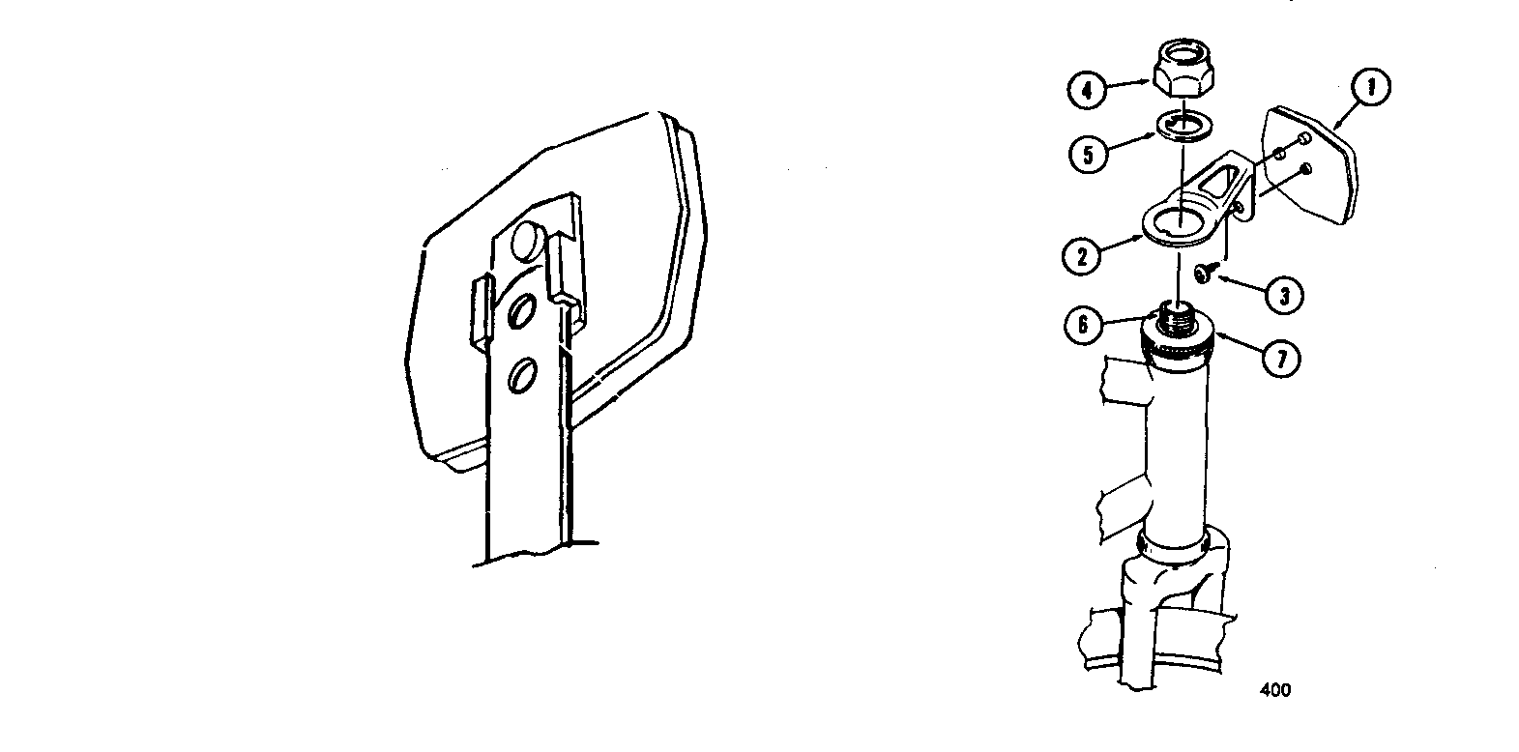

Reflector Assembly
Assemble the reflector to the front reflector bracket. Instructions apply to these models:
- Touring 1000
- Touring 2000
- Touring 3000
WARNING: Install the reflector as shown or it will not operate correctly.

Snap In Style
- Push the reflector onto the reflector bracket.
- Make sure the stud on the reflector goes into the hole of the bracket with a snapping sound.

Screw In Style
- Put the reflector onto the reflector bracket.
- Make sure the studs on the back of the reflector go into the holes of the reflector bracket.
- Put the screw through the bracket and into the reflector.
- Tighten screw.

